CS 305 Module Two Coding Assignment Template
Amy Marquis
11.6.25
CS-305

Assignment #2: Static Testing

Instructions
Replace the bracketed text with the relevant information in your own words. If you choose to include images or supporting materials, make certain to insert them in all the relevant locations in the document.

Run Dependency Check
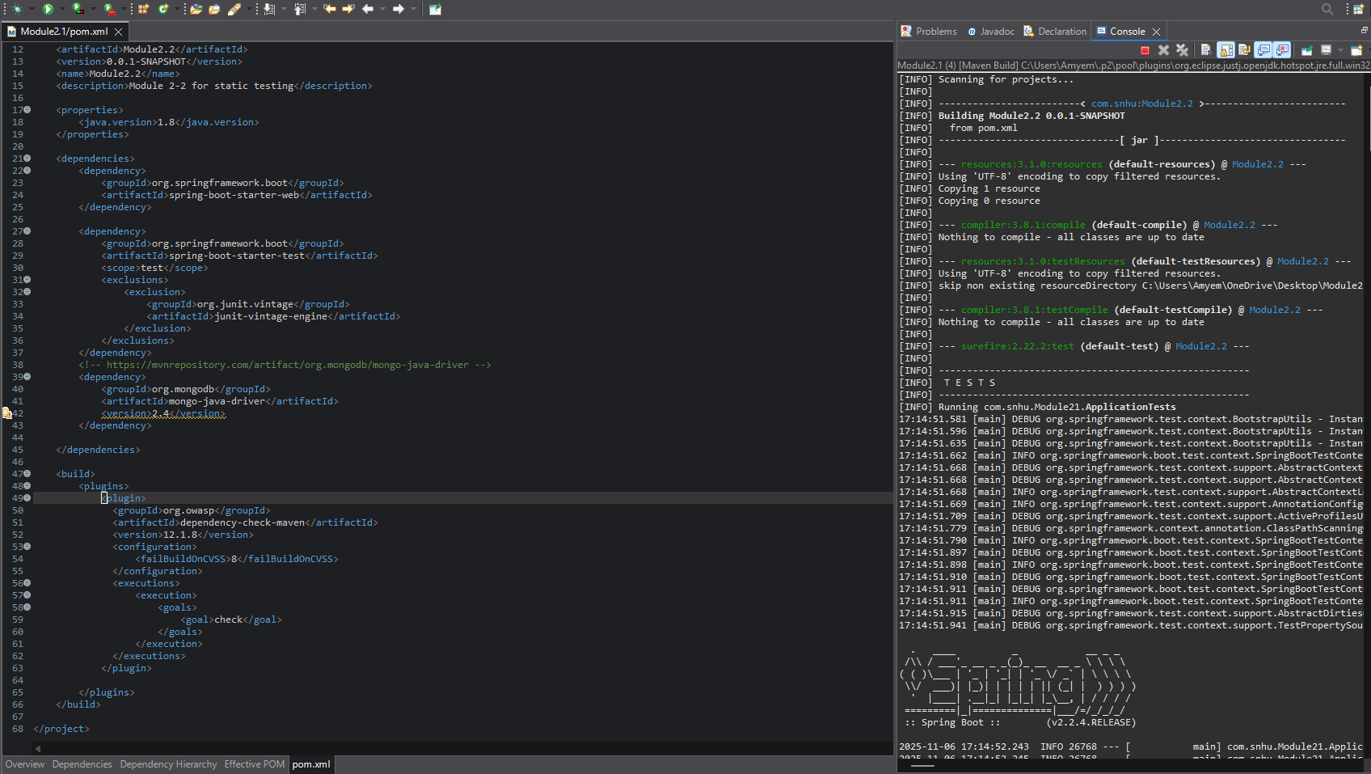

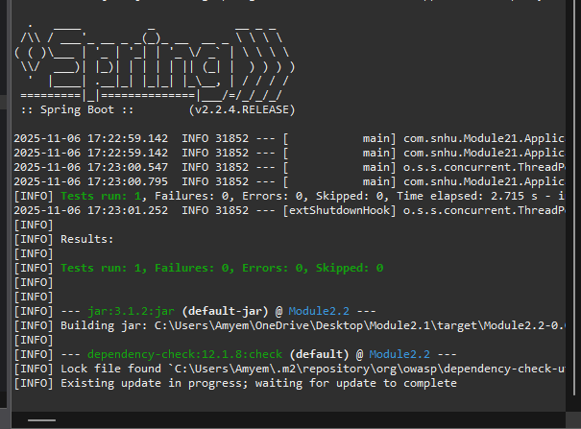

Document Results

These are the results I got from running the Dependancy tracker out of Maven.
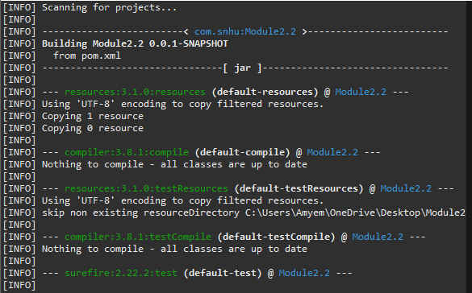

Analyze Results

- During a dependency check, you may find false positives that don't indicate immediate security risks but are worth investigating. Filtering these helps you concentrate on more critical security issues. Most vulnerabilities can be fixed by upgrading to the latest software version.

- hibernate-validator-6.0.18.Final.jar
Summary: A flaw in Hibernate Validator version 6.1.2.Final allows invalid EL expressions to be evaluated as valid, enabling attackers to bypass input sanitation in error messages.
Remediation: Pass user input as an expression variable using HibernateConstraintValidatorContext or upgrade to the latest version.

- jackson-databind-2.10.2.jar
A vulnerability in Hibernate Validator version 6.1.2.Final allows invalid Expression Language (EL) expressions to be treated as valid. This issue enables attackers to circumvent input sanitation in error messages. To address this problem, pass user input as an expression variable using HibernateConstraintValidatorContext, or upgrade to the latest version of Hibernate Validator.

- log4j-api-2.12.1.jar
Summary: There is a vulnerability in Apache Log4j's SMTP appender that allows for improper certificate validation. This can lead to man-in-the-middle attacks, which may expose log messages.
Remediation: To fix this issue in earlier versions, set the system property mail.smtp.ssl.checkserveridentity to true for verifying hostnames.
Additionally, Hibernate Validator version 6.1.2.Final accepts invalid Expression Language (EL) expressions. This lets attackers bypass input checks. To resolve this, use HibernateConstraintValidatorContext to handle user input or upgrade to the latest version of Hibernate Validator.

- snakeyaml-1.25.jar
The Alias feature in SnakeYAML version 1.18 introduces the capability for entity expansion during a load operation, which is linked to the issue identified in CVE-2003-1564. To address this concern, it is recommended to update to the latest version of SnakeYAML.

- spring-aop-5.2.3.RELEASE.jar
Summary: Certain versions of the Spring Framework (5.2.0-5.2.8, 5.1.0-5.1.17, 5.0.0-5.0.18, and 4.3.0-4.3.28) have a vulnerability (CVE-2015-5211) related to Cross-Site Request Forgery (CSRF). This issue stems from weak session management, allowing attackers to forge requests using a `jsessionid` path parameter, depending on the web browser. Remediation: To mitigate this vulnerability, update to the latest stable release of the Spring Framework for enhanced CSRF protections and overall security improvements. Regular updates are essential for a secure application.

- spring-core-5.2.3.RELEASE.jar
Summary: In Spring Framework versions 4.3.0 - 5.2.8 and older unsupported versions, protections against RFD attacks (CVE-2015-5211) may be bypassed depending on the browser with a jsessionid path parameter.
Remediation: Update to the latest version.

- tomcat-embed-core-9.0.30.jar
Summary: Apache Tomcat versions 10.0.0-M1 to 10.0.6, 9.0.0-M1 to 9.0.46, and 8.5.0 to 8.5.66 had issues with parsing the HTTP transfer-encoding request header under certain conditions. This could lead to a vulnerability known as request smuggling when used in conjunction with a reverse proxy. The specific problems included:

- Tomcat incorrectly ignored the transfer-encoding header if the client indicated that it would only accept an HTTP/1.0 response.
- Tomcat accepted the identity encoding.
- Tomcat failed to verify that if chunked encoding was present, it was the final encoding applied.

Remediation: It is recommended to update to the latest version.

- tomcat-embed-websocket-9.0.30.jar
Summary: Versions Apache Tomcat 10.0.0-M1 to 10.0.6, 9.0.0.M1 to 9.0.46, and 8.5.0 to 8.5.66 did not properly parse the HTTP transfer-encoding header, potentially allowing request smuggling with a reverse proxy. Key issues included ignoring the transfer encoding header for HTTP/1.0 responses and not ensuring chunked encoding was the final encoding.
Remediation: Upgrade to the latest version.

